Recette du quatre-quarts

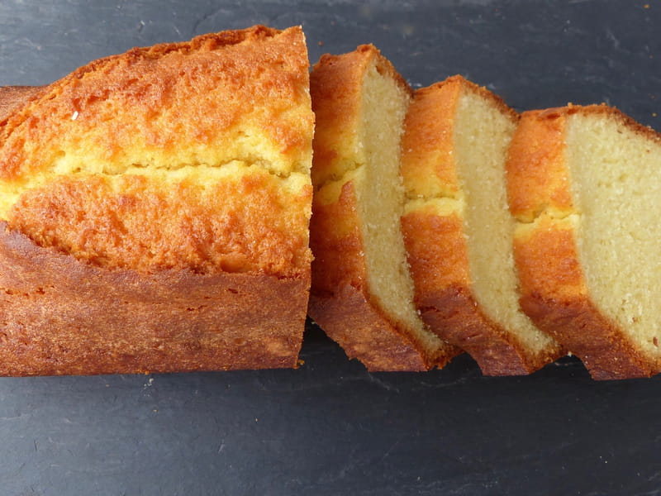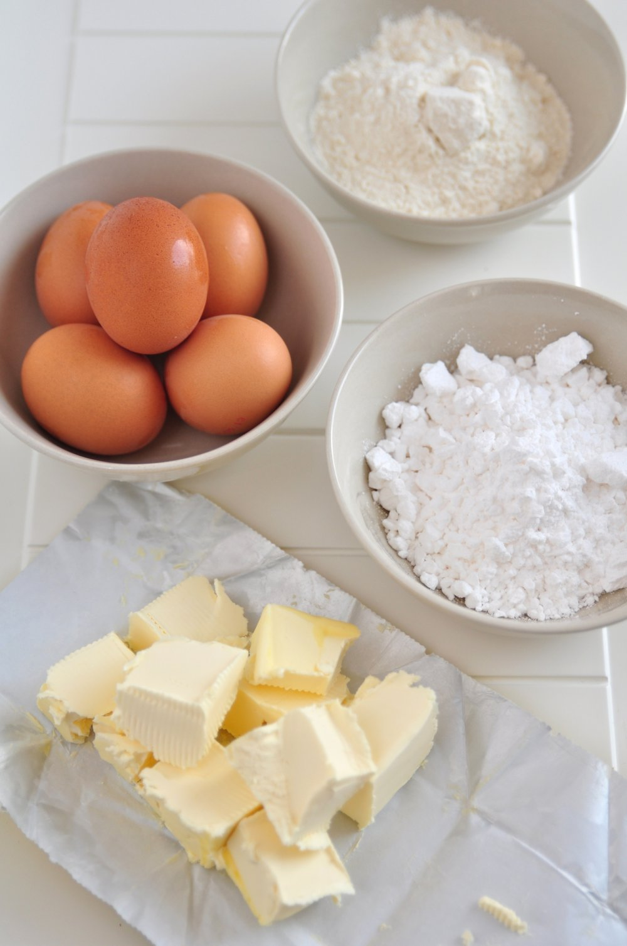

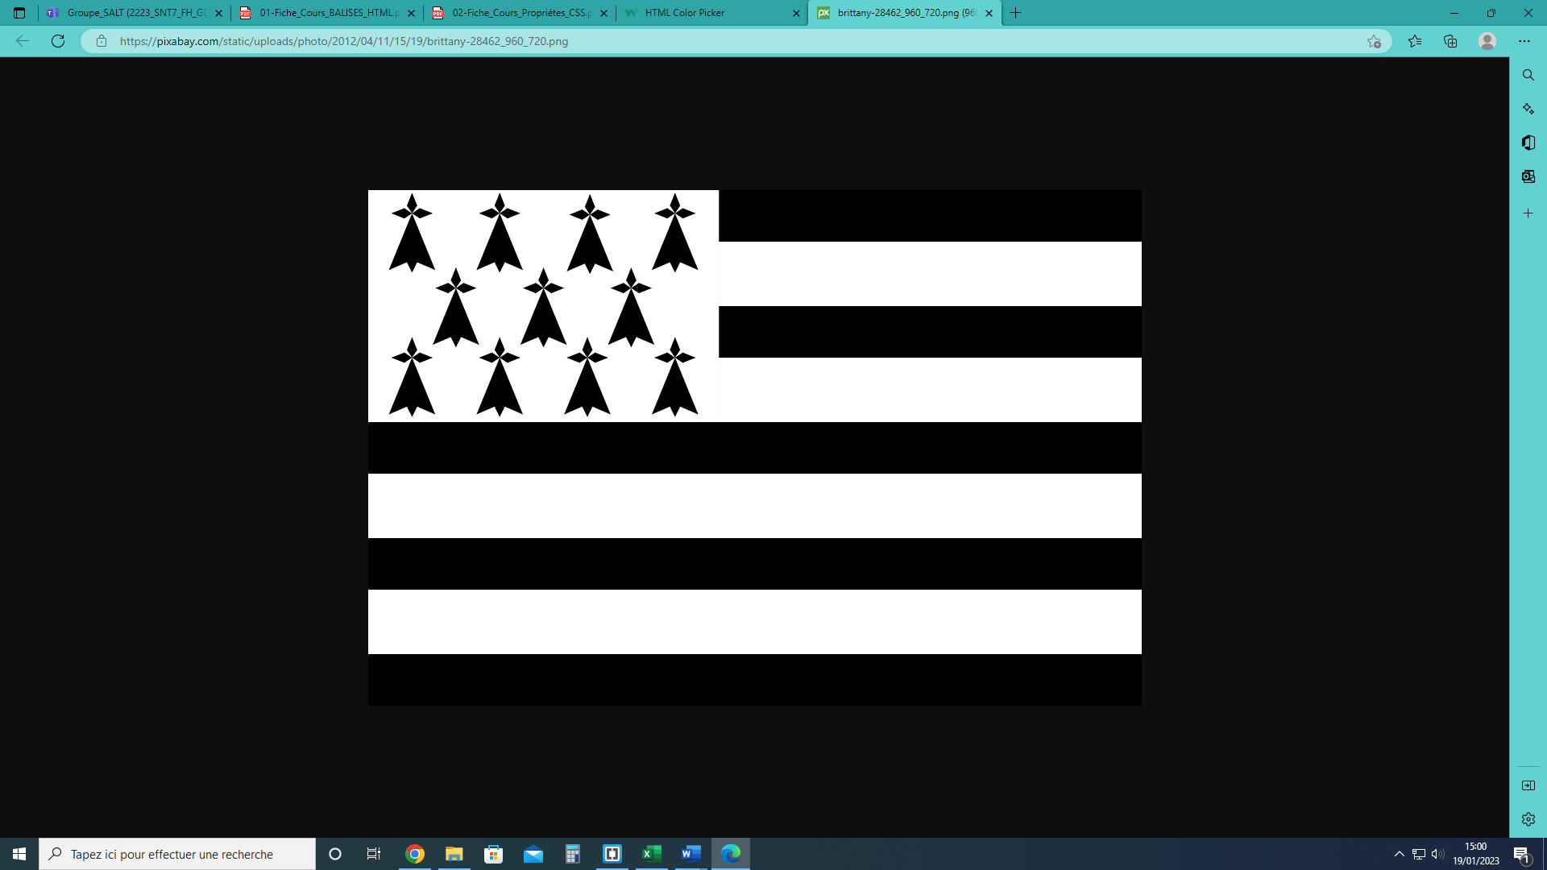

[HTML Color Picker (w3schools.com)](https://www.w3schools.com/colors/colors_picker.asp)